Practical: - 7

Aim: - Create an Employee table (Emp_id, Emp_Name, Emp_Email, Emp_Add, Emp_Dept, Salary );

SQL> create table employee2 (Emp_id INT PRIMARY KEY, Emp_Name Varchar (100), Emp_Email varchar (100), Emp_Add Varchar (255), Emp_Dept INT, Salary INT);

SQL> desc employee2;

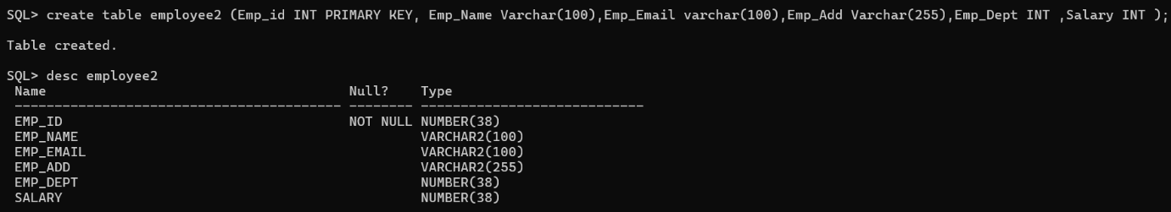

SQL> insert into employee2 (Emp_id, Emp_Name, Emp_Email, Emp_Add, Emp_Dept, Salary) values (1,'Ravi', 'ravi@gmail. com', ' Ap’, 10, 60000);

SQL> insert into employee2 (Emp_id, Emp_Name, Emp_Email, Emp_Add, Emp_Dept, Salary) values (2,'Raju’, ‘raju@gmail.com', ' Ap’, 10, 50000);

SQL> INSERT INTO employee2 (Emp_id, Emp_Name, Emp_Email, Emp_Add, Emp_Dept, Salary) values (3,'Riya', 'riya@gmail.com', 'up’, 20, 40000);

SQL> INSERT INTO employee2 (Emp_id, Emp_Name, Emp_Email, Emp_Add, Emp_Dept, Salary) values (4, 'Rupa', 'rupaa@gmail. com', ' Haryana’, 20, 70000);

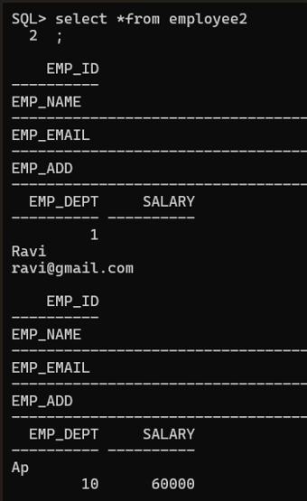SQL> INSERT INTO employee2 (Emp_id, Emp_Name, Emp_Email, Emp_Add, Emp_Dept, Salary) values (5,'sai’, ‘sai@gmail.com', 'Haryana’, 10, 70000);

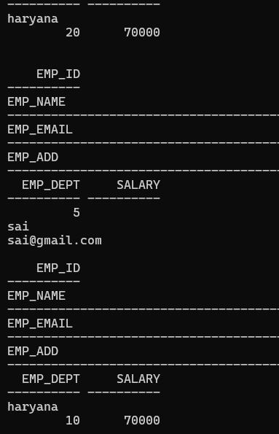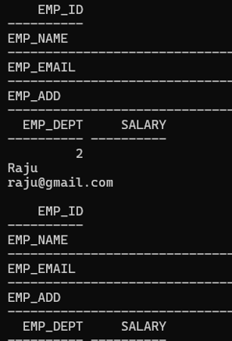

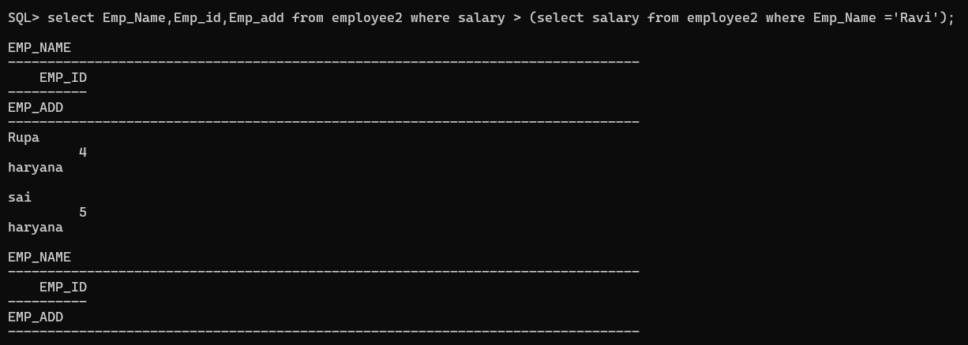SQL> select Emp_Name, Emp_id, Emp_Add from employee2 where salary > (select salary from employee2 where Emp_Name ='Ravi');

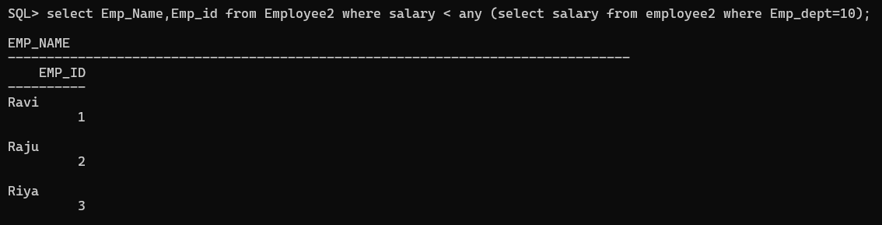SQL> select Emp_Name, Emp_id from Employee2 where salary < any (select salary from employee2 where Emp_Dept=10);

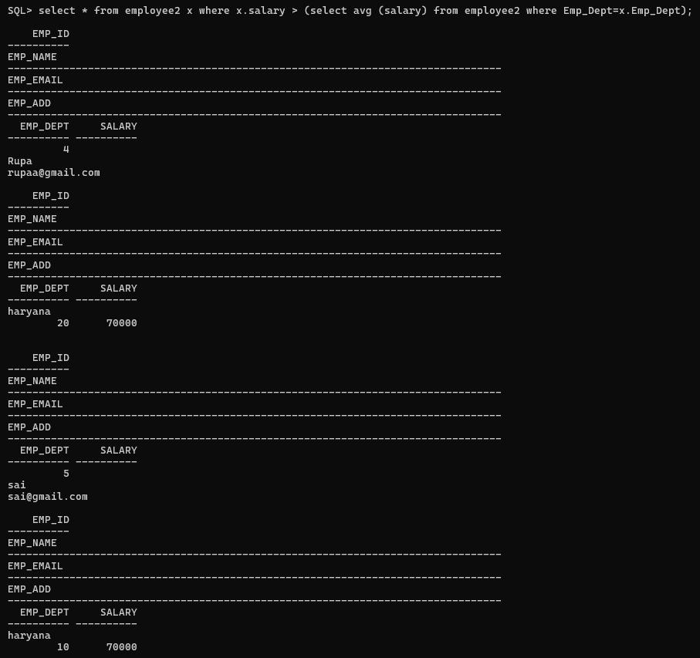SQL> select * from employee2 x where x. salary > (select avg (salary) from employee2 where Emp_Dept=x. Emp_Dept);